Injection cap w/controlled break

INLETS

BY: ASHAR AHMED JAVED

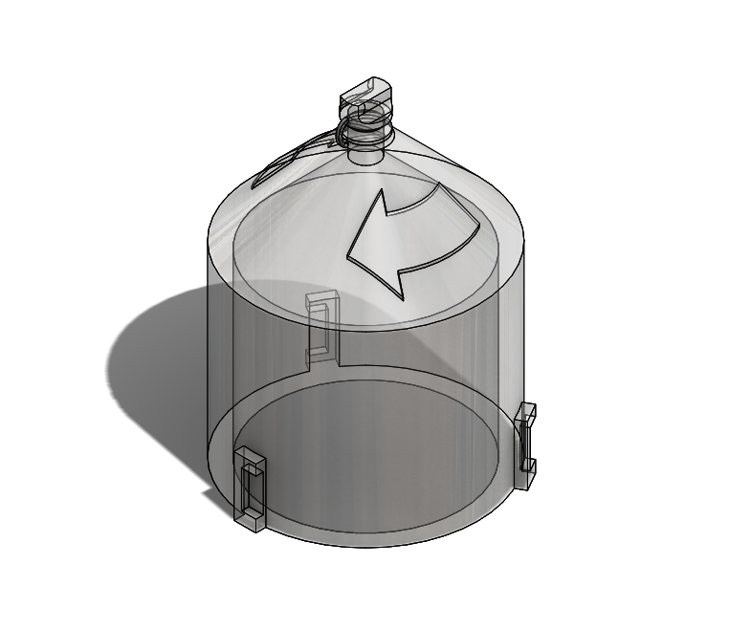

PURPOSE:

The purpose of this study was to enhance the design to prevent the cap from clogging the injector nozzle.

This study utilizes a provided design and FEA-Finite Element Analysis software was used to identify undesirable feature characteristics through computer simulation. This document presents chronologically the process of identification of engineered features.

**Material**: Acrylic (MPa Threshold 45 ≤)

|  |  |  |  |  |
| --- | --- | --- | --- | --- |
| |  | | --- | |  |   **Model name: Injector Breakaway Head**  **Current Configuration: Default** | | | |
| **Solid Bodies** | | | |
| **Document Name and Reference** | **Treated As** | **Volumetric Properties** | **Document Path/Date Modified** |
| **Split Line2** | **Solid Body** | **Mass:0.00223629 kg**  **Volume:1.86358e-06 m^3**  **Density:1,200 kg/m^3**  **Weight:0.0219157 N** | **Feb 14 05:55:08 2017** |
|  |  |  |  |

|  |  |  |  |  |  |  |  |  |  |  |  |  |  |  |  |  |  |  |  |  |  |  |  |  |  |  |  |  |  |  |  |  |  |  |  |  |  |  |  |  |
| --- | --- | --- | --- | --- | --- | --- | --- | --- | --- | --- | --- | --- | --- | --- | --- | --- | --- | --- | --- | --- | --- | --- | --- | --- | --- | --- | --- | --- | --- | --- | --- | --- | --- | --- | --- | --- | --- | --- | --- | --- |
| **Loads and Fixtures**  | **Fixture name** | **Fixture Image** | **Fixture Details** | | --- | --- | --- | | **Fixed-1** |  | |  |  | | --- | --- | | Entities: | **1 face(s)** | | Type: | **Fixed Geometry** | | | **Resultant Forces**   |  |  |  |  |  | | --- | --- | --- | --- | --- | | **Components** | **X** | **Y** | **Z** | **Resultant** | | **Reaction force(N)** | **-3.53961e-06** | **-1.41823e-07** | **3.24287e-06** | **4.80262e-06** | | **Reaction Moment(N.m)** | **0** | **0** | **0** | **0** | | | |  | **Load name** | **Load Image** | **Load Details** | | --- | --- | --- | | **Force-1** |  | |  |  | | --- | --- | | Entities: | **2 face(s)** | | Type: | **Apply normal force** | | Value: | **20 lbf** | | |

ANALYSIS – A: F.O.S

Injection cap

Results: The Injection cap seems to break within our yield limit.

During analysis we discovered the 10 LBF torque with a material yield strength of MPa 45 exceeds by a factor of 6.67 times at the critical places.

SUMMARY: PASS.

| Name | Type | Min | Max |
| --- | --- | --- | --- |
| Factor of Safety | Automatic | 2.000e+00  Node: 1 | 2.000e+00  Node: 1 |
| **Injector Breakaway Head-Static-Factor of Safety-Factor of Safety1** | | | |

ANALYSIS – B: Von Mises

Injector Breakaway Head STRESS ANALYSIS (REVISED/OPTIMIZED DESIGN)

Results: The TV Mounting Bracket appears to be designed well about yield.

SUMMARY: PASS

| Name | Type | Min | Max |
| --- | --- | --- | --- |
| Stress1 | VON: von Mises Stress | 5.840e-03N/mm^2 (MPa)  Node: 2563 | 1.508e+01N/mm^2 (MPa)  Node: 179 |
| **Injector Breakaway Head-Static-Stress-Stress1** | | | |

ANALYSIS – C

Injector Breakaway Head DISPLACEMENT ANALYSIS

Results: The TV Mounting Bracket bends in the downward direction approximately by 4 mm, which may indicate a stiffer material should be considered.

SUMMARY: PASS

| Name | Type | Min | Max |
| --- | --- | --- | --- |
| Displacement1 | URES: Resultant Displacement | 0.000e+00mm  Node: 1 | 3.960e-01mm  Node: 597 |
| **Injector Breakaway Head-Static-Displacement-Displacement1** | | | |

SUMMARY: With the optimized design, we managed to prevent the clogging while keeping the material cost and design alteration to a minimum!